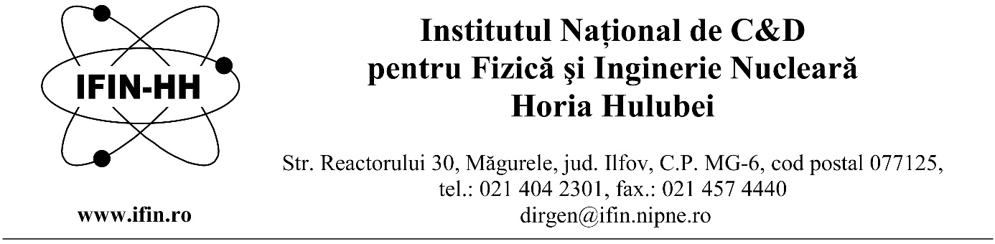
“Horia Hulubei” National Institute for Research and Development in Physics and Nuclear Engineering is hiring a scientific research assistant for a definite duration, until 30 September 2022, full time, at the Radiopharmaceutical Research Centre within the Applied Nuclear Physics Department (DFNA).
1 position of Scientific Research Assistant:
Requirements to fill the position:
- Master in Pharmacy (MPharm);
- PC operating skills (Office) and specialized programs;
- very good command of English, advanced level (writing and speaking);
- Knowledge of the topics specified in the announcement.
Main responsibilities:
- Fulfil project's tasks allocated by the project manager;
- On-site training and honing in the field of the position topics;
- Participation in the execution of the research activities foreseen in the contract (radio-syntheses, organic/bio-inorganic chemistry, processes automation, physical and chemical analyses by liquid and gas chromatography, in-vitro biological testing of radiopharmaceuticals, testing PET-CT imaging on small animal models
*The work is to be performed by using open radiation sources, tumor cell lines and animal models;
- Attending the work meetings convened by the project manager;
- Taking part in the data processing and dissemination of the results generated within the project;
Topics:
- Organic chemistry: syntheses of organic compounds belonging to the class of halides, amino acids, peptides, amines, carboxylic acids, alcohols / phenols, saccharides;
- Radiochemistry: radiochemical syntheses and radiolabeling;
- Automation of chemical processes;
- Bio-inorganic chemistry: metal coordination compounds;
- Analitical chemistry: liquid and gas chromatography - HPLC, TLC, GC;
- Physical Chemistry and instrumental analysis: physical and chemical analyses by magnetic resonance imaging (MRI), IR and UV-VIS, spectroscopy, electronic microscopy, mass spectrometry (MS);
- Guidelines for Good Manufacturing Practice, drug development and clinical studies.
Skills and abilities:
Ability to work in an organizational structure, highly regulated fields, hierarchical setting, and rigorous compliance with regulations of the Quality Management System;
Motivated, thoroughly, competent person, showing high capacity to be part of a multidisciplinary team, dealing with multiple tasks and deadlines, pay attention to details.
Applications will contain the following documents:
- Request for competition registration (specifying the position code/name of department) – can be found at www.nipne.ro/careers/jobs/jobs.php;
- Copies of the study diplomas (baccalaureate included);
- Curriculum Vitae;
- Copy of the identity document/passport.
The evaluation procedure consists of a written test and an open discussion (interview) in the field of the position topics.
The interview can be held only by the candidates who have obtained a minimum score of 7 out of 10 in the written test. The candidates who have obtained a minimum score of 7 at the subsequent interview are declared admitted.
The final score is calculated as arithmetic mean of the scores obtained for the written test and the interview and must be at least 7. The candidate who has obtained the highest score among the candidates competing for the same position is admitted, provided that they have obtained the minimum necessary score.
The applications will be sent to e-mail address resum@nipne.ro, until 18.03.2022.
The written test and the interview will take place on 21.03.2022, at 10.00.
Further information can be obtained by phone 021/404.61.78 or
021/404.23.00 int. 5612, 5610 and to e-mail address resum@nipne.ro.
References
1. Nuclear and Radiochemistry Book, 2012, Authors: József Kónya and Noémi M. Nagy
https://www.sciencedirect.com/book/9780123914309/nuclear-and-radiochemistry#book-description
Chapter 12 An Introduction to Nuclear Medicine
2. Compuşi marcaţi şi radiofarmaceutici cu aplicaţii în medicina nucleară, autori: A.T. Balaban, I. Gălăţeanu, G. Georgescu, Ligia Simionescu, 1979
Capitolul 5 Trecerea de la compuşi marcaţi la compuşi radiofarmaceutici
Capitolul 6 Controlul de calitate al compuşilor marcaţi radiofarmaceutici
3. Ghid de Bună Practică de Fabricaţie pentru medicamente de uz uman/
Guidelines for Good Manufacturing Practice
Anexa 1 FABRICAŢIA MEDICAMENTELOR STERILE/ Annex 1 Manufacturing of sterile medicines
Anexa 3 FABRICAȚIA MEDICAMENTELOR RADIOFARMACEUTICE/ Annex 3 Manufacturing of radiopharmaceuticals
Note: Any other similar reference of the subjects is accepted.

